**2019**

User Guide:

Big Bank

Table of Contents

**Features**

**Main Page**

**Create an Account**

**Login**

**Welcome Page**

**Open Account**

**Close Account**

**Deposit a Check**

**Transfer Money**

**ATM**

**Withdraw money**

**Log out**

**FAQ**

**Access Big Bank Corp**

[**http://bigbank.gregariux.com**](http://bigbank.gregariux.com)

**Features**

The objective of this online banking site is to allow customers basic banking actions. The actions included within the bank are to create and close bank accounts, transfer money between accounts, deposit checks, and withdraw from an ATM. All of these features can be reached once a user creates an account and is signed in to the Big Bank website.

Every account holder is able to create three different types of accounts in their account: credit, checking, and savings. Users are able to view their balance from the various accounts. Accounts can also be closed when no longer needed.

Big Bank allows users to control many different types of these accounts under one username. Users are able to manage their various balances from different accounts and transfer funds from account to account.

Big Bank works on a trust system with all users/partners for depositing money. Users must upload a photo of the check or money that is going to be deposited. Another required input here is that users are required to input the amount that is going to deposit to confirm the amount going into their account.

Big Bank is accessible at any computer and also is the ATM. Users can access the ATM function to withdraw their money by utilizing their account username and Big Bank generated PIN.

**Main Page**

**The initial page of the website is called the Main Page. This page has the background of Big Bank Corp broken down into two sections, “Why choose Big Bank?” and “Who are we?”. The top of the page has three options the user can select: about, create an account, and log in. The about page will bring the user back to the Main Page. The create an account screen will bring the user to a page where they can sign up for Big Bank. The login page will bring the user to a page that will allow users type in their account username and password that will give access to the accounts they are managing. Alternatively for logging in and signing in, the user is able to click log in and sign up in the middle of the page to access both these features. The bottom of the main page consists of the same functions as the top of the screen where a user is able to access without having to scroll all the way up again. The bottom of the pages is also where one is able to locate the address of Big Bank Corp and the names of the 8 CEOs of this company.** 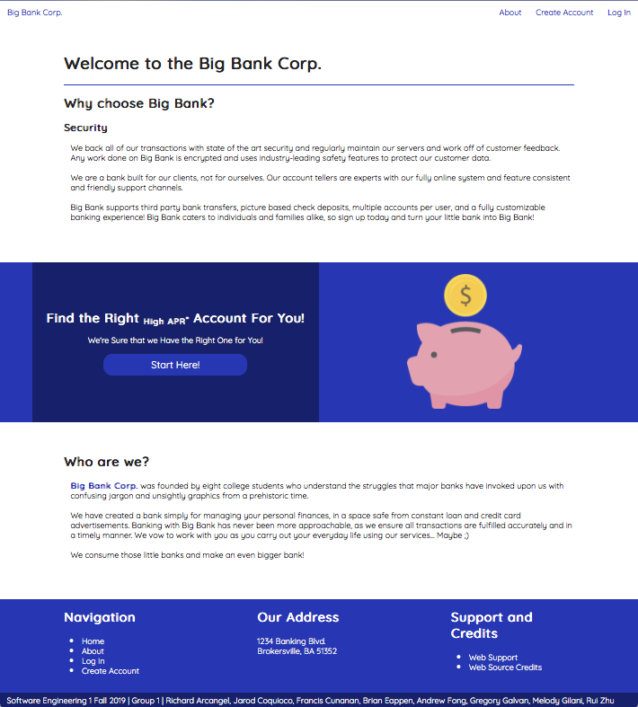

**Create an Account**

**From the home page, users can select either “Log In/ Sign Up” or “Create Account” to begin creating an account.**

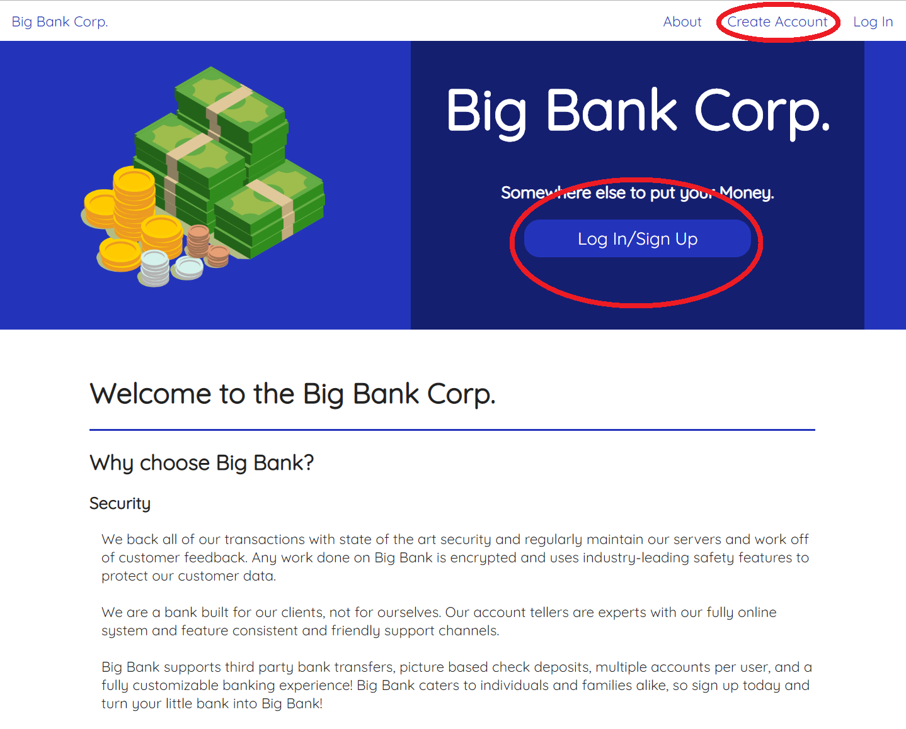

**If “Log In/Sign Up” is selected, press “Sign Up” to create an account. Creating the “Create Account” brings the user directly to the sign up page.**

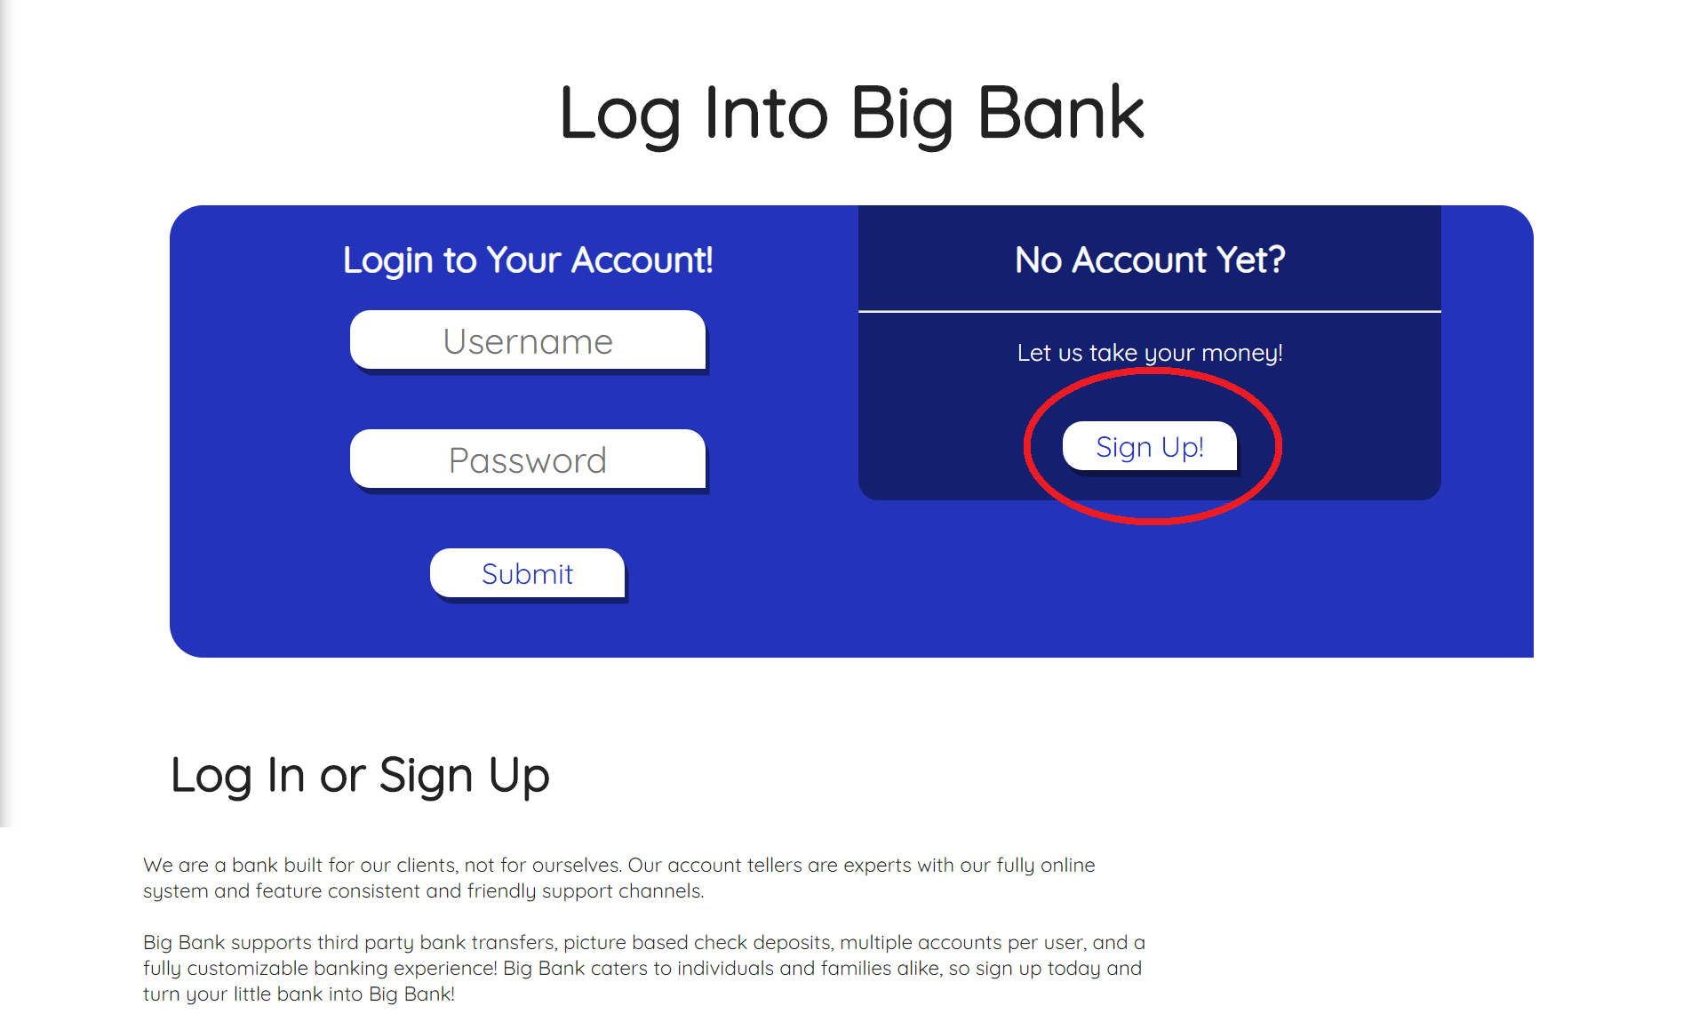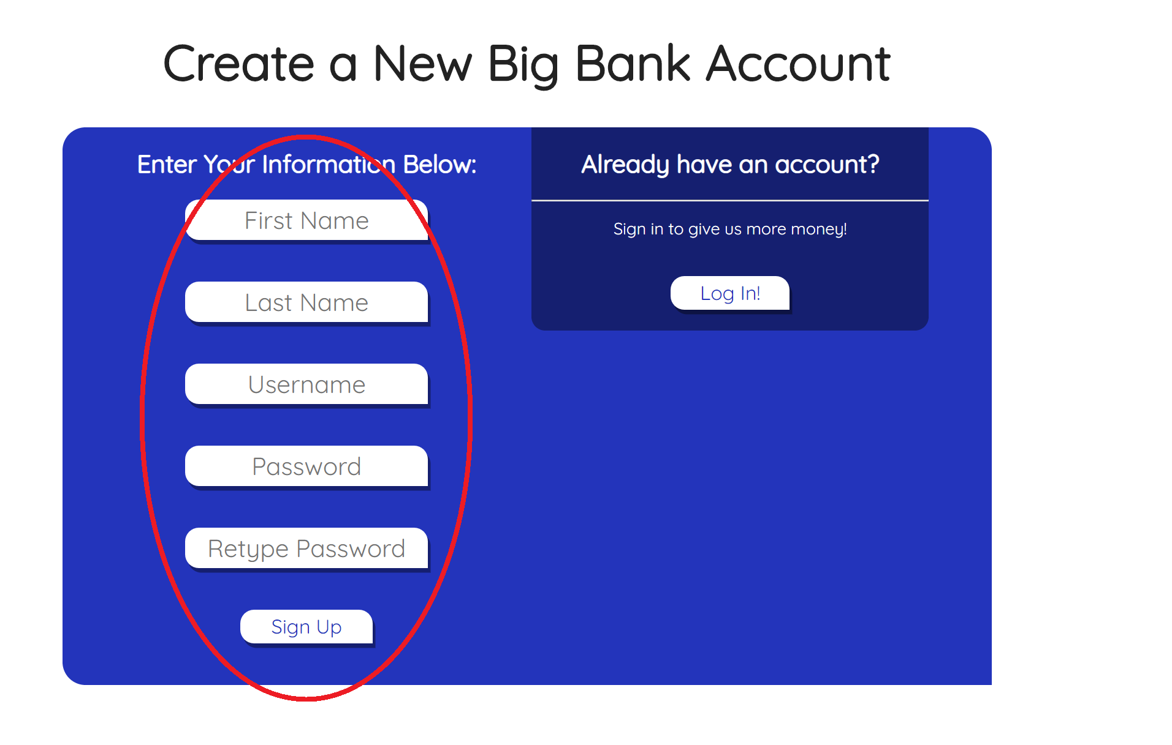

**Once in the sign up page, the user is required to fill out all required information to create an account: First name, last name, a unique username, password, and password confirmation. Click each box to type in the required information. The signup page will indicate any errors such as if the username already exists or if the inputted passwords are not confirmed. Click “Sign Up” to finish creating an account.**

**Log In**

**Logging into an account can only be executed once an account has been made. Please refer to the previous step if an account has not been made. From the home page, click “Log In/ Sign Up” in the middle of the page or “Log In” in the top right corner.**

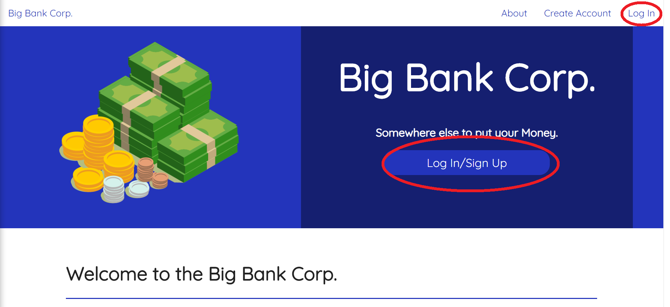

**Enter both username and password into the “Username” and “Password” box. Once typed in, you can press enter or click “Submit” to log in. Logging in will bring you into the Welcome page.**

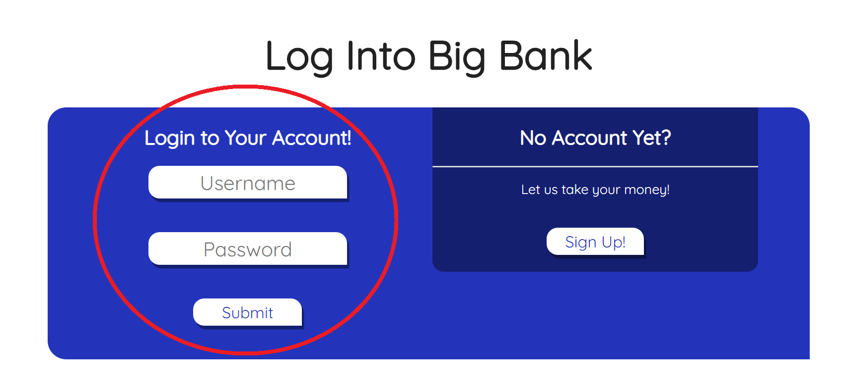

**Welcome Page**

**The Welcome Page will host your accounts and display recent transactions from all accounts. It also features a user-exclusive ATM Pin, which can be used to visit the ATM. Link featured at the top right corner of the Welcome Page. Next to the ATM link you’ll see your name. Clicking on your name will reveal a drop down menu with options to view My Accounts, Transfer Money, Deposit a Check, and view Transaction history. To return to the Main Page click on “Big Bank Corp.” at the top left corner. You can also hover the mouse over your name to open the drop down menu of all the actions you are able to do to sign in.**

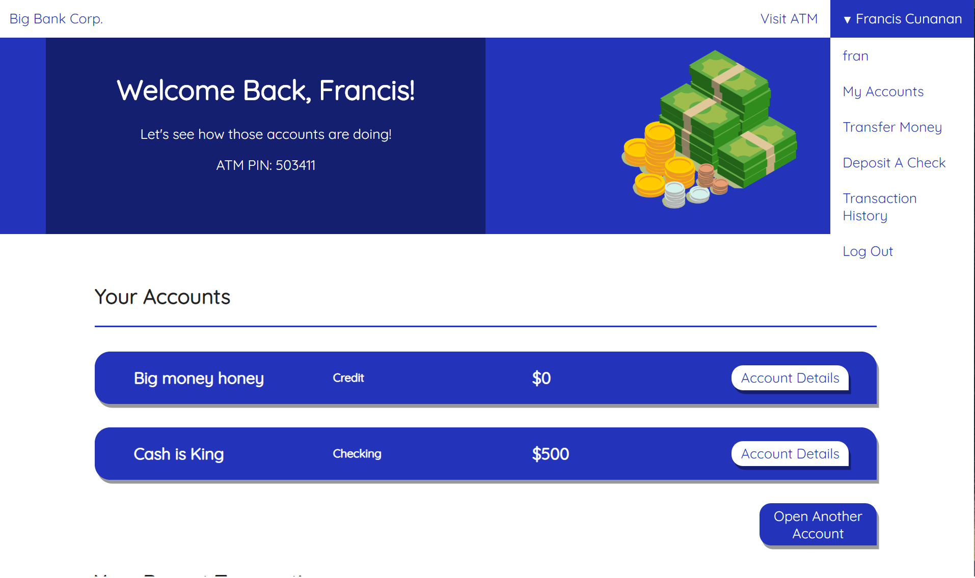

**Opening your first Big Bank account can be done from this page by clicking “Open Your First Account”**

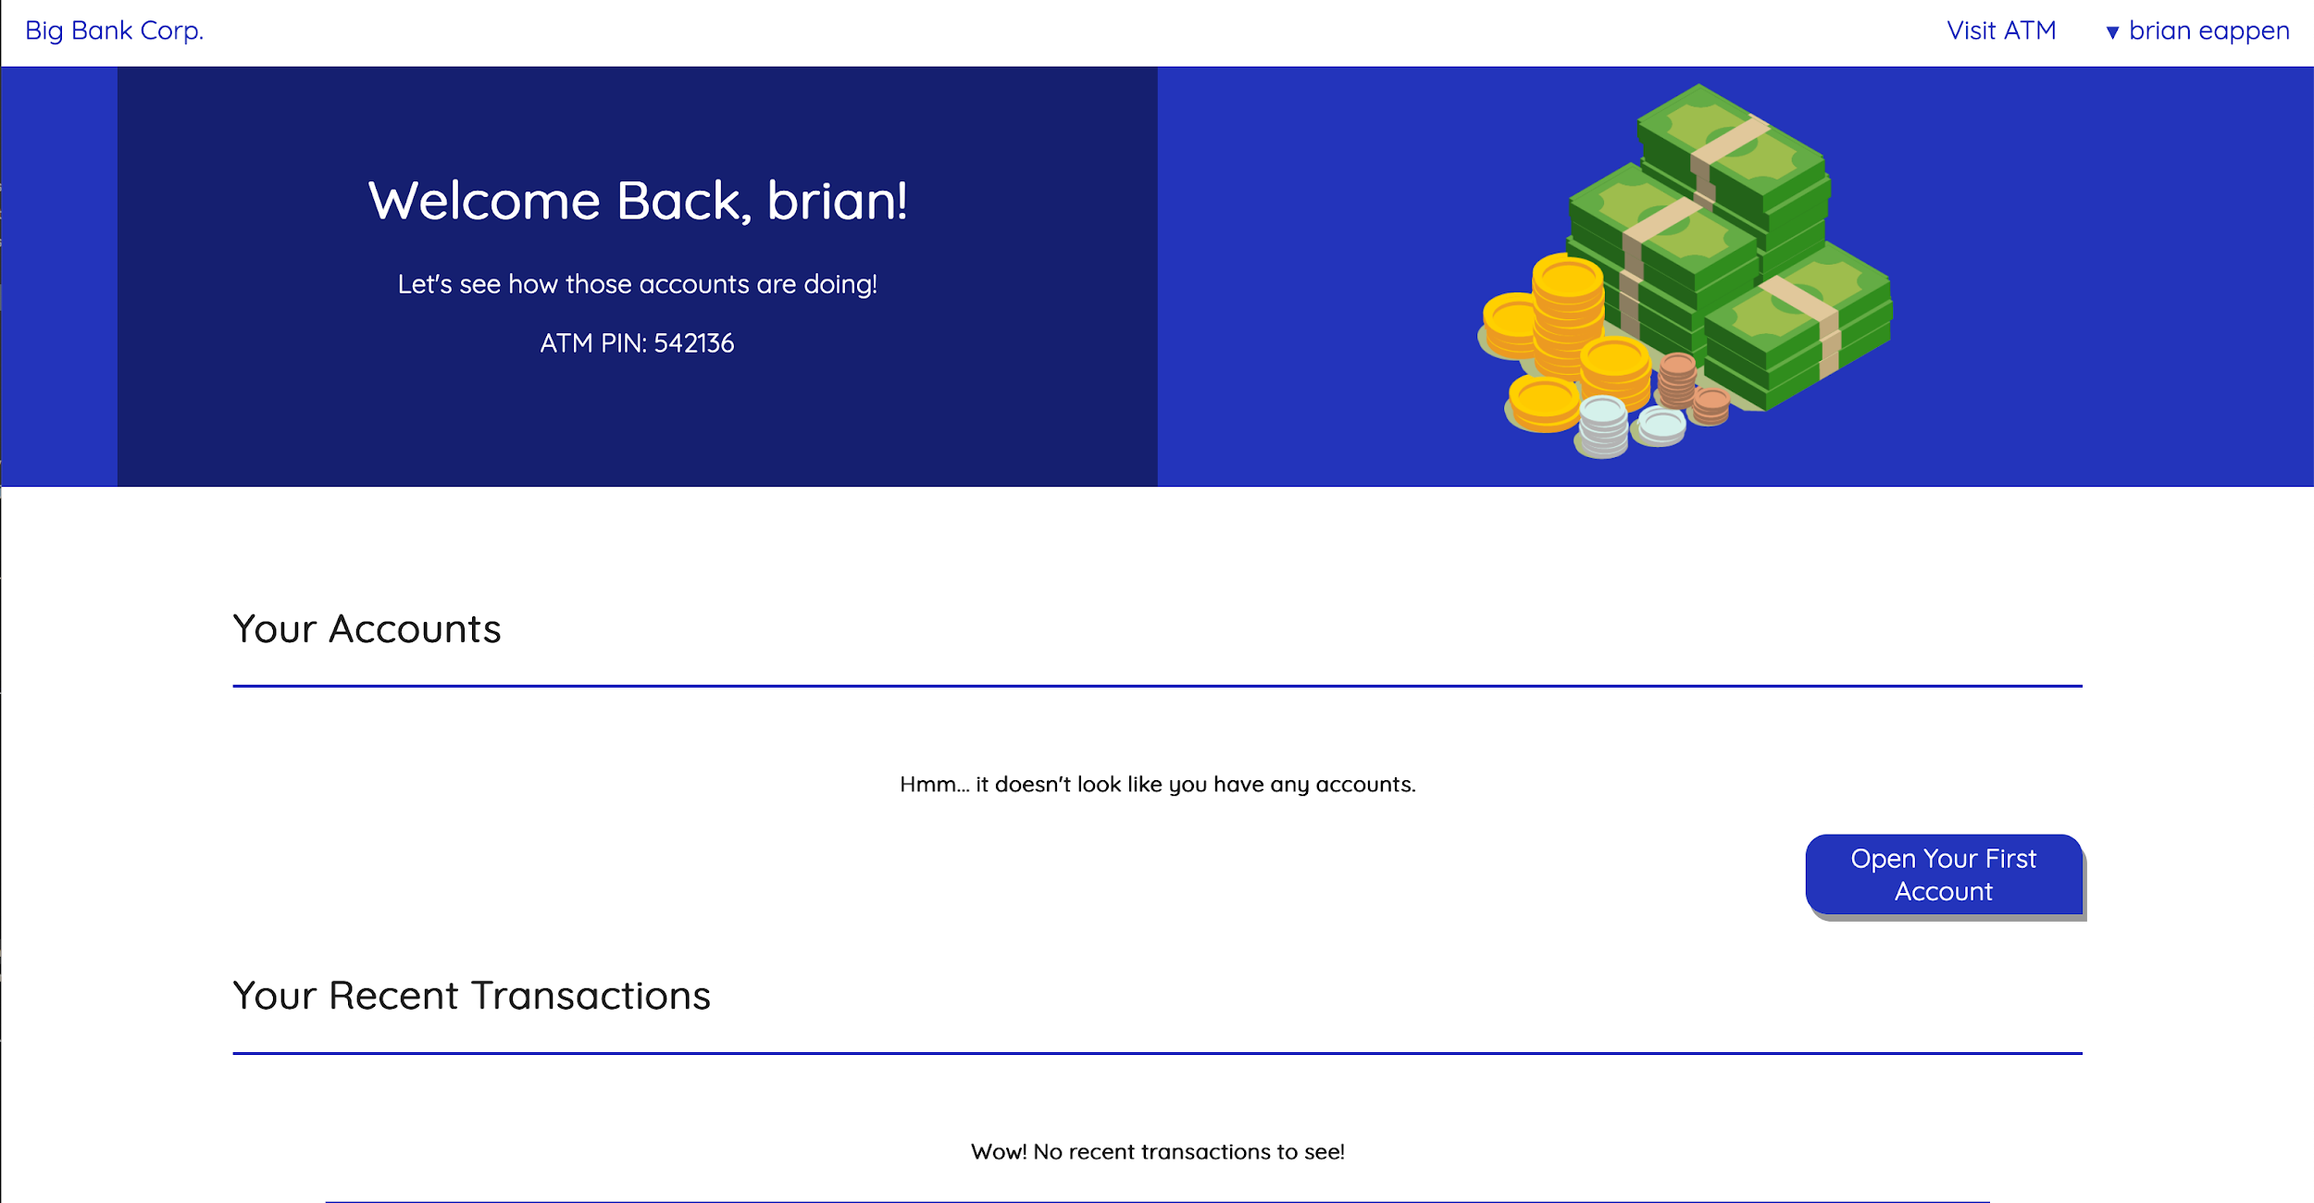

**Open Account**

**New Bank accounts can be opened with a user-defined account description, and specifying an account type, with the choices of Checking, Savings, or Credit. Every account opening requires re-verification with the initial username and password.**

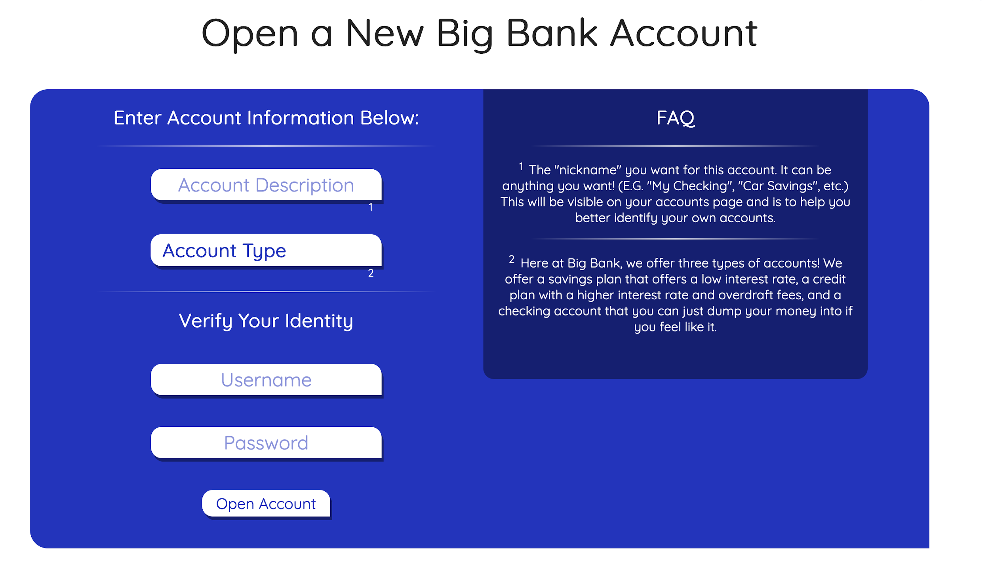

**After opening your first account, you will be routed back to the Welcome Page where you can see your new account under My Accounts, and option to open another account.** 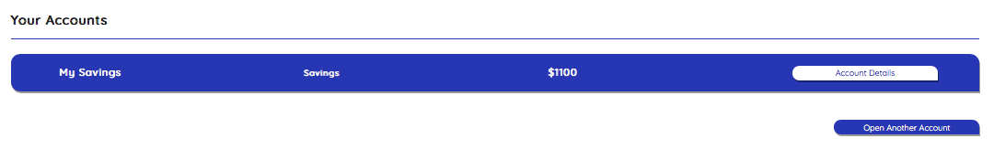

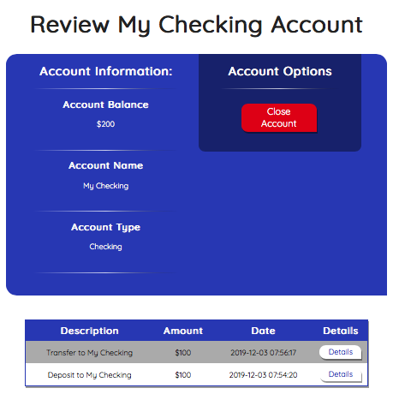

**Every new account created has an option review and see details of that account, by clicking “Account Details.”**

**This page includes; total balance, account name, account type, recent transactions, and option to close account.**

**Close Account**

**If you decide you want to close one of your accounts, you want to start by locating the account on the welcome page and clicking account details. Verify you are reviewing the right account at the top and click “Close Account.” A pop up will appear asking what account to deposit the remaining amount, and requires re-verification with the initial username and password.** 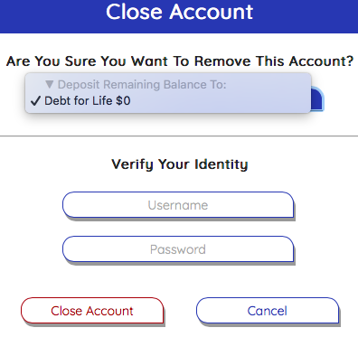

**Once an account is closed, that same account can not be reopened. A new account will need to be opened, and the appropriate amount of money will need to be transfered.**

**Deposit a Check**

**After opening an account, the user will be allowed to deposit checks to add to the balance of the account that the user wants.**

**To deposit a check, you start by clicking on your name at the top right corner, open the drop down menu, and click “Deposit a Check.”**

**The user has to enter the dollar amount that they want to input into their account and what account they want to add the balance to. The user will then be prompted to insert a picture of their check for verification. After this, the user will have to type in their login information for the check to be processed and reviewed.**

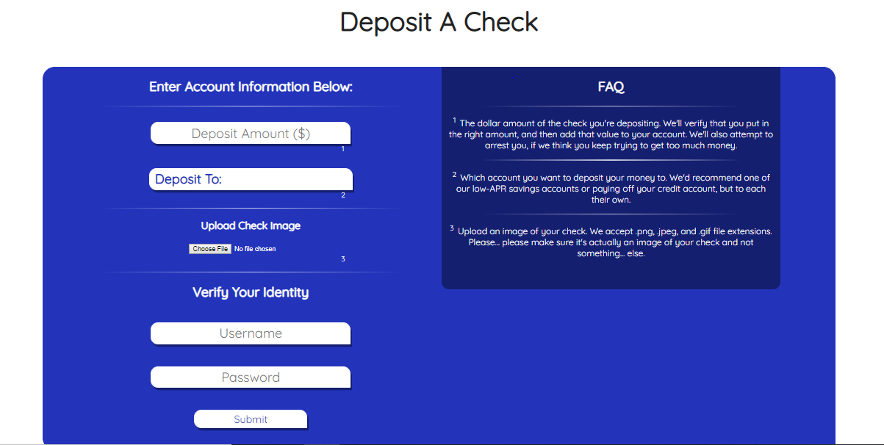

**The user will also be allowed to check their deposit history through transaction history page. looking up the complete checking deposit information can be done by checking the “Details” button.**

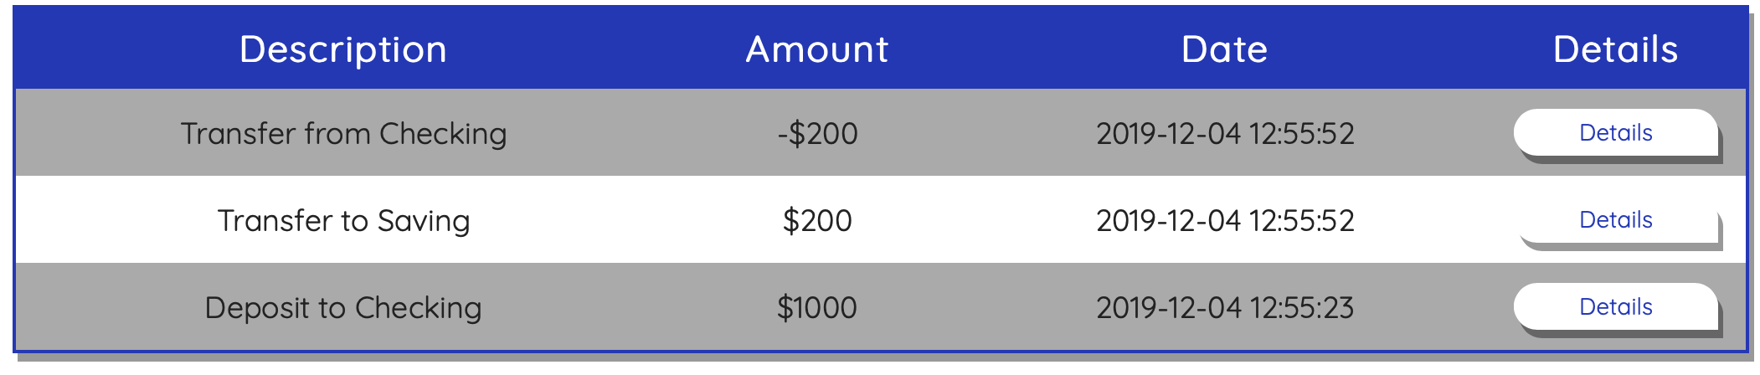

**Once the user checked the “Details” button, all the transaction information will be shown which include amount deposited, account deposited to, transaction time, and the check image.**

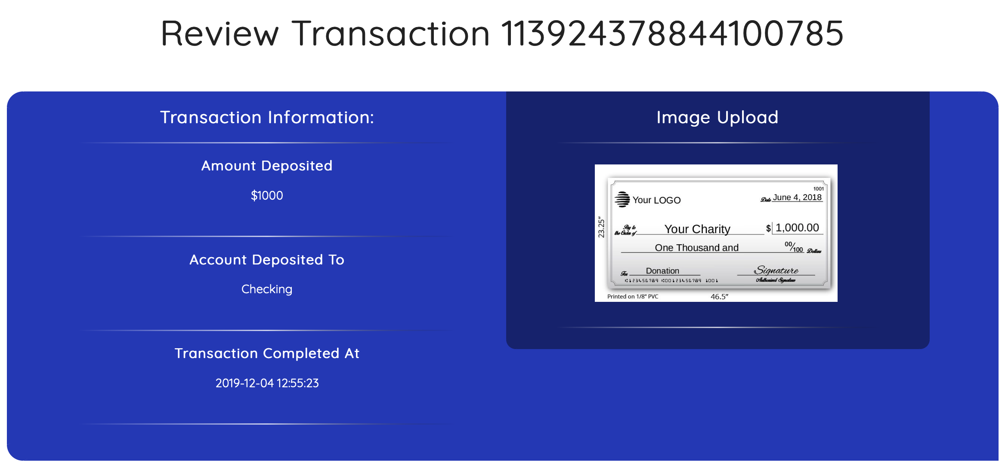

**Transfer money**

**After opening an account, the user will be allowed to transfer money or pay off the negative balance between accounts. By checking the “Submit” button, the user will enter the transfer money page.**

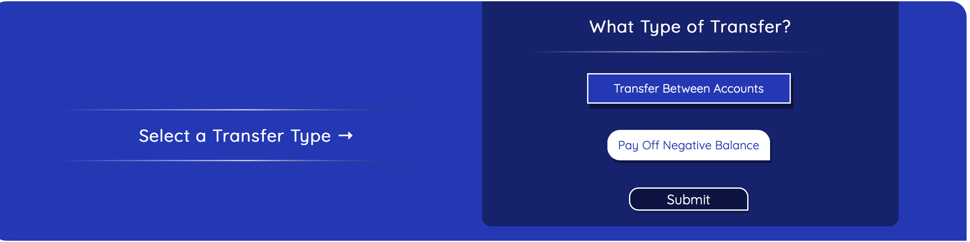

**The user has to choose the withdrawal and deposit account and then enter the dollar amount that they want to transfer. The pump-out options will show all account names and amounts. After this, the user will have to type in their login information for the check to be processed and reviewed. Noticed that all the transfer can be overdraft. Once the account overdraft, the amount will be shown as a negative number.**

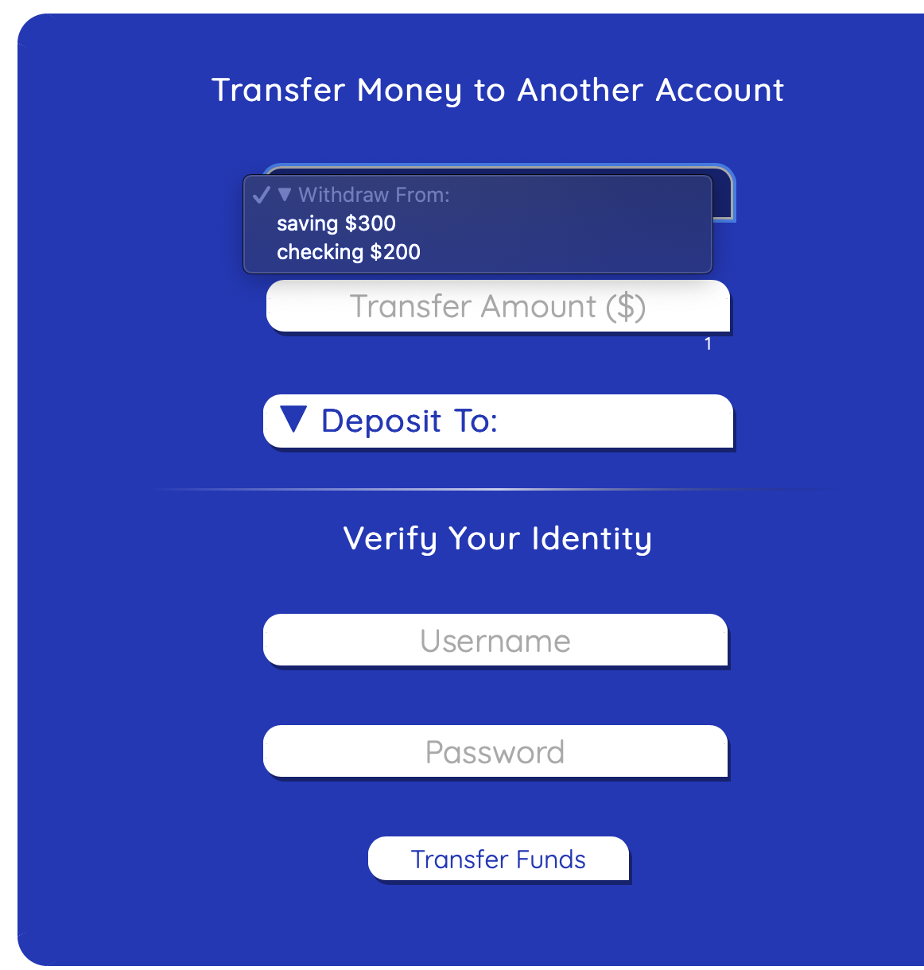

**ATM**

**After opening an account, the user will be allowed to visit our ATM. ATM can be found at the right top of any Bigbank page.**

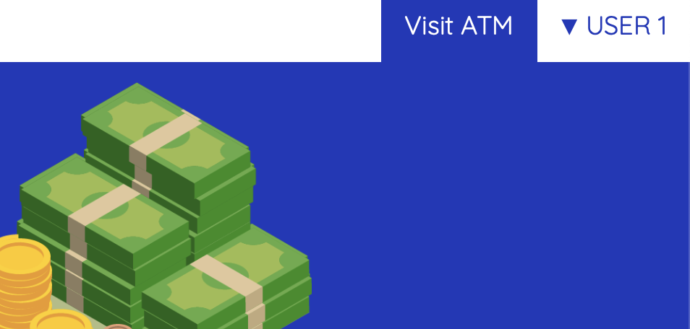

**In order to process the ATM, the user will need their “PIN” to log in to the ATM page. “PIN” can be found at the left-top side of “My Account” page.**

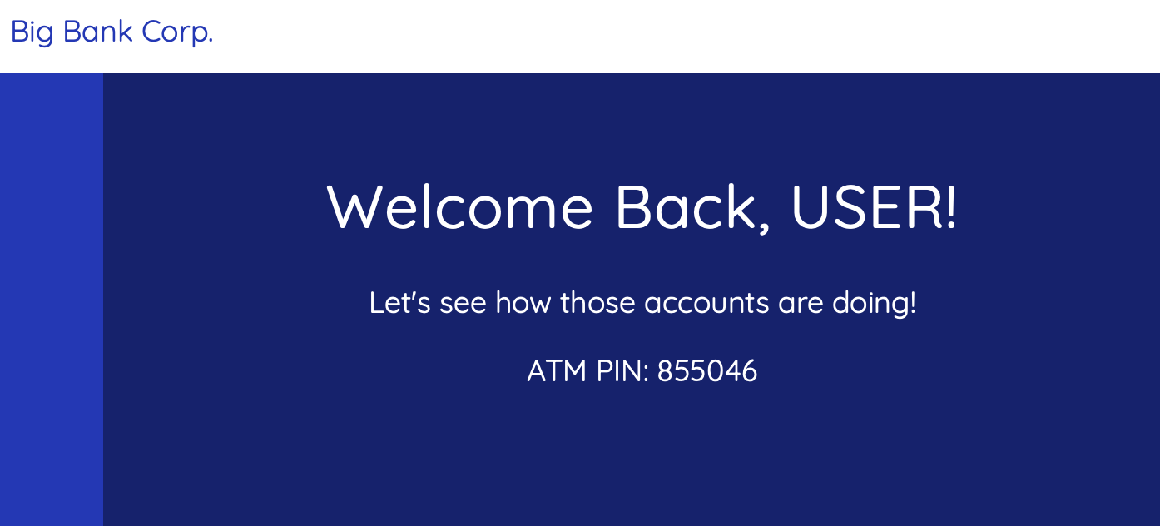

**After checking the “Visit ATM” button, the user can enter the PIN on the security virtual keyboard. If you decide that you do not want to use the ATM, press “That’s A Big Bank” to return to the main page.**

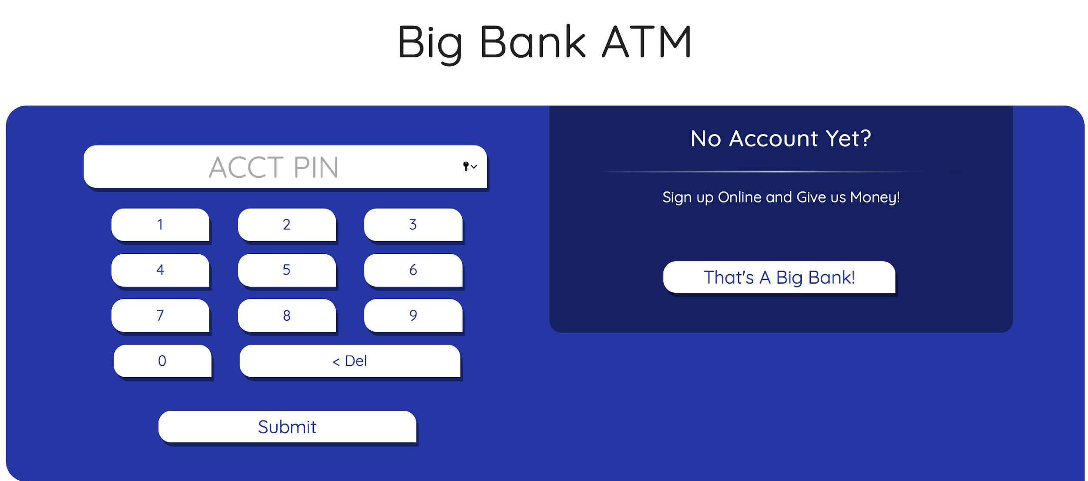

**Withdraw Money**

**On the ATM front page, the user will see an option to withdraw money.**

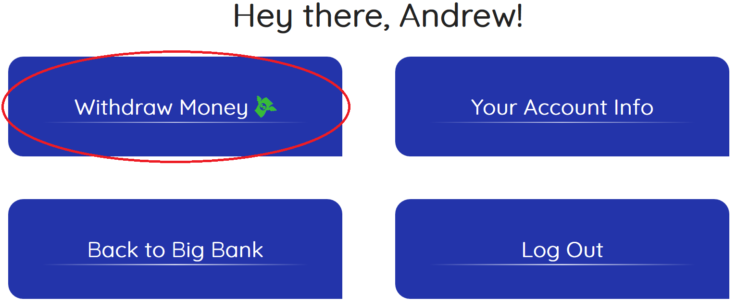

**Choosing this option will bring up the page shown below for the user to select an amount of money to withdraw and which account to withdraw the money from.**

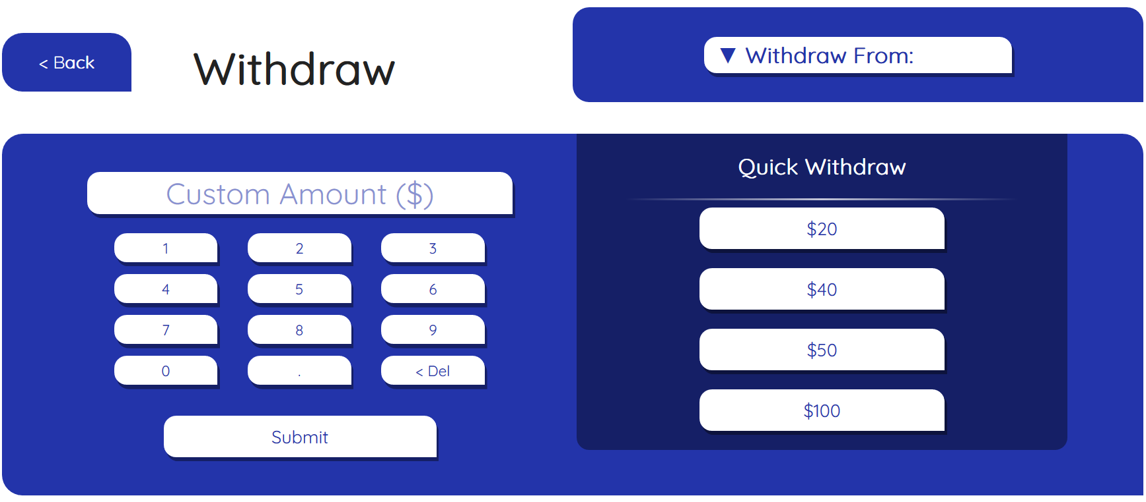

**Log Out**

**When the user is ready to log out of the ATM, they can press the “< Back” button on the Withdraw page and then press “Log Out” on the front page.**

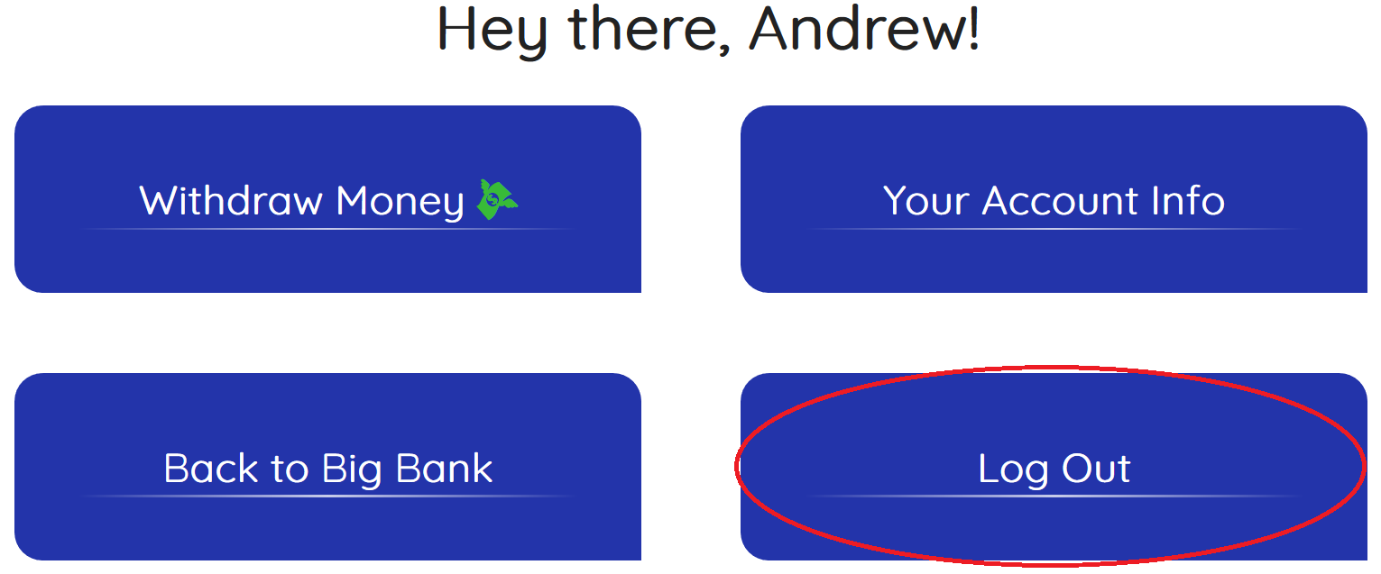

**If they are trying to log out from the website, then they can hover over their name on the top right corner to open the drop-down menu and click on “Log Out” at the bottom.**

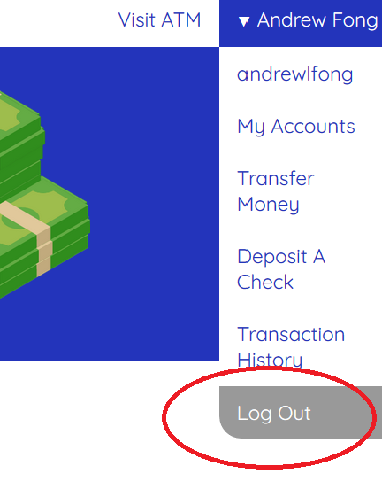

**Frequently Asked Questions**

**Q: How can I access my account?  
A:** [**http://bigbank.gregariux.com/**](http://bigbank.gregariux.com/landing/)

**Q: When will my funds be available?  
A: Funds are available immediately upon deposit.**

**Q: Do I need a debit card?  
A: No, you can access the ATM at anytime with your PIN number.**

**Q: How many accounts am I able to open?  
A: As many as you want.**

**Q: Where do I check my pin?  
A: Your pin is located on the Welcome Page under where we welcome you with your name at the top left.**

**Q: Is any of this money real?  
A: No.**